RIPHAH INTERNATIONAL UNIVERSITY


Faculty of Computing
Object Oriented Programming Lab
Lab 8
Polymorphism
Submitted By: Khadija Binte Asif
SAP ID: 77954
Submitted To: Miss Nayab Khalid

Lab Manual Development Team

Supervision and Coordination

Hira Jaffar
Lecturer
Faculty of Computing

Lab Designers
Nayab Khalid Kayani
Lecturer
Faculty of Computing

6. Tasks:
Task 1: Hospital Appointments
At City Care Hospital, patients book appointments in three ways: by name only (a general doctor, today), by name and doctor (today), or by name, doctor and day number. Create a class Hospital and overload the book() method three times to handle these cases. Each version should print a confirmation message. Test all three versions in main().

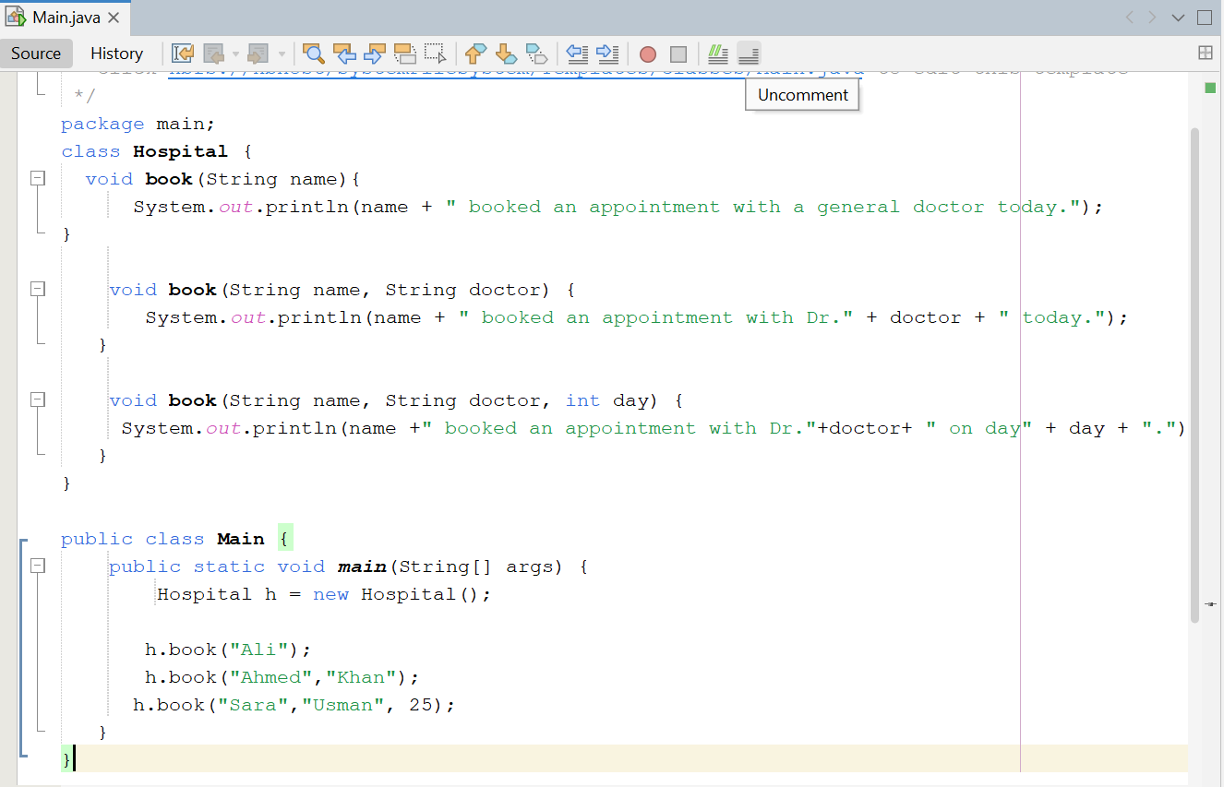
Output:
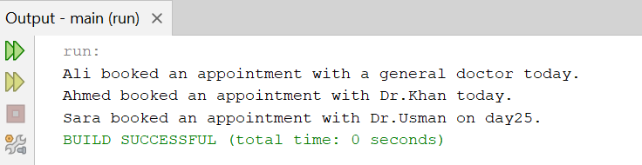

Task 2: Ride Fare Calculator
A ride app charges a different rate per kilometre for each vehicle. Create a base class Ride with a method calculateFare(int km) that charges 25 per km. Then create subclasses Bike (20 per km), Car (40 per km) and Rickshaw (30 per km), each overriding the method and returning the fare as a double. In main(), store all three in a Ride[] array, loop through it, and print each fare for 10 km.
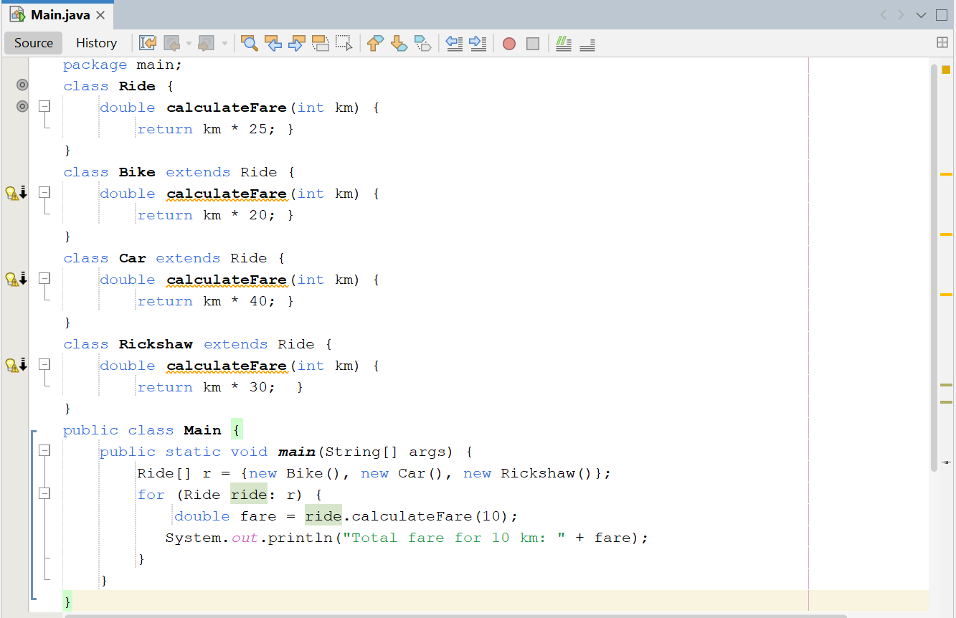
Output:
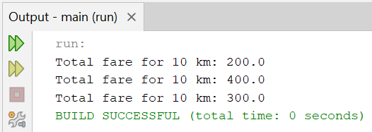

Task 3: University Fee with Scholarship
A university calculates student fees with or without a custom discount percentage. Create a class Fee with two overloaded methods: calculate(double tuition) returns the tuition unchanged, and calculate(double tuition, double percent) returns the tuition minus that percentage. Scholarship students get 20% off by default, so create a subclass ScholarshipFee that overrides only the one-parameter method. In main(), use a tuition of 50000 and test both classes with both methods.
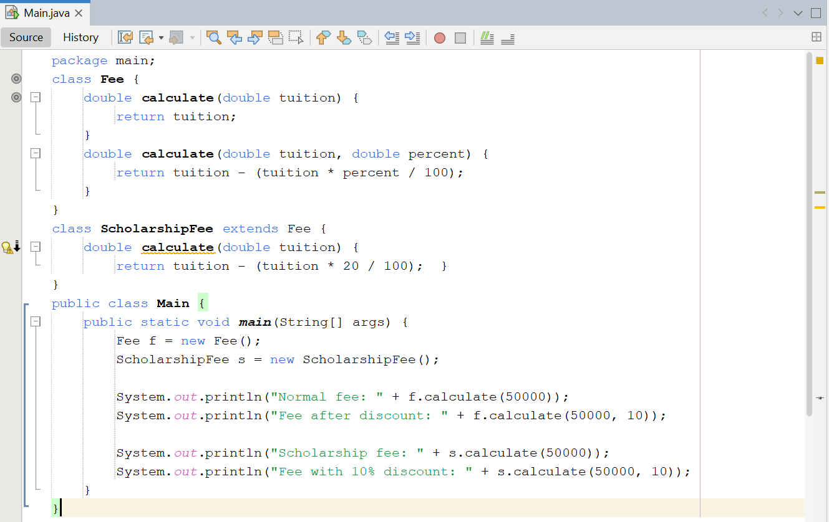
Output:


